Chapter 16, Problem 56.

Calculate i_{o}(t) for t > 0 in the network of Fig. 16.79.

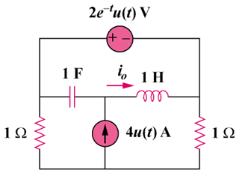

Figure 16.79
For Prob. 16.56.

